**Visual programming Assignment**

**Submission Date (18 / 9, 2024)**

**BY**

**Agha Salahuddin 22011556-087**

**IT 303 ( Visual Programming )**

**BS-Degree IT 5th B Section**

**Submitted To**

**Sir Nauman Mazhar**

 **Write a program in C# to print your Name / roll no / Class / section**

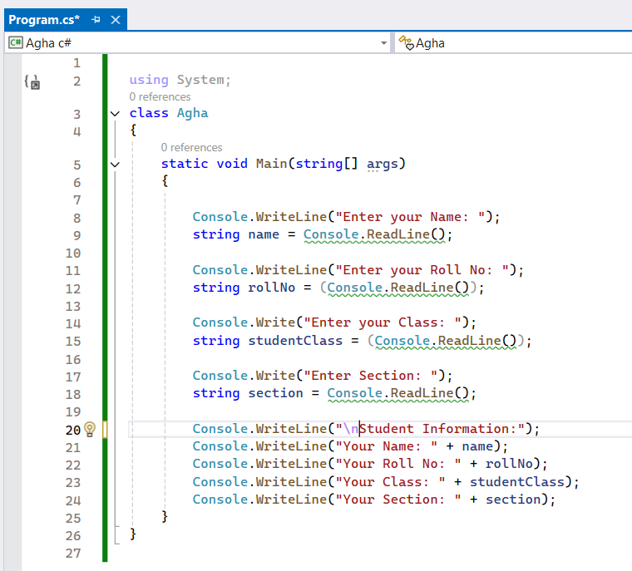

**Output :**

